Q2. Input a no from the user and print if its even or odd.

Eg : no: 5 Output: it is odd No: 10 Output: it is even

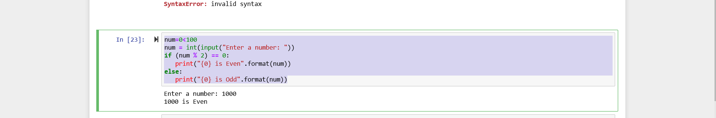

Q1. Write a user driven program which will will ask users to input two no and perform some calculation

# Program make a simple calculator

# This function adds two numbers

def add(x, y):

return x + y

# This function subtracts two numbers

def subtract(x, y):

return x - y

# This function multiplies two numbers

def multiply(x, y):

return x * y

# This function divides two numbers

def divide(x, y):

return x / y

print("Select operation.")

print("1.Add")

print("2.Subtract")

print("3.Multiply")

print("4.Divide")

while True:

# Take input from the user

choice = input("Enter choice(1/2/3/4): ")

# Check if choice is one of the four options

if choice in ('1', '2', '3', '4'):

num1 = float(input("Enter first number: "))

num2 = float(input("Enter second number: "))

if choice == '1':

print(num1, "+", num2, "=", add(num1, num2))

elif choice == '2':

print(num1, "-", num2, "=", subtract(num1, num2))

elif choice == '3':

print(num1, "*", num2, "=", multiply(num1, num2))

elif choice == '4':

print(num1, "/", num2, "=", divide(num1, num2))

break

else:

print("Invalid Input")